**Automation Of Inventory Management Process**

**Dedication**

I dedicate this manuscript to my parents (Mr. and Mrs. Fonebi), and all whose moral support has helped me complete this entire course.

**Acknowledgments**

I would like to acknowledge the assistance of for their support during my stay at the university. Finally, I wish to thank the Almighty who has seen me through with this project

**Contents**

**1 Introduction 1**

1.1 Background 1

1.2 Problem Statement 2

1.3 OBJECTIVES 2

1.3.1 General Objective 2

1.3.2 The specic objectives include: 2

1.4 Scope 2

1.5 Signicance of the study 3

**2 LITERATURE REVIEW 4**

2.1 Introduction 4

2.2 Management of Information Systems 4

2.3 Inventory Control Systems 4

2.4 Types of Inventory Manual Systems 5

**3 METHODOLOGY 8**

3.1 Introduction 8

3.2 Data Collection 8

3.3 Analysis and Design 9

3.4 Development and Implementation 9

**4 SYSTEM STUDY AND INVESTIGATION 10**

4.1 System Study 10

4.1.1 Problem of the existing system 11

4.1.2 User Requirements of the New System 13

4.1.3 Functional Requirements of the Proposed System 13

4.1.4 Non functional requirements 14

4.2 System requirements 15

4.2.1 Hardware requirements 15

4.2.2 Software requirements 15

4.3 System Design 16

4.3.1 Design objectives 16

4.3.2 Design features of the database 17

4.3.3 Mapping relationships 20

4.3.4 Final database schema 22

|  |  |  |  |
| --- | --- | --- | --- |
|  | 4.4 System Implementation | | 27 |
|  | 4.4.1 Security and accessibility to the database | | 27 |
|  | 4.4.2 Implementation | | 27 |
|  | 4.4.3 Software life-cycle model | | 27 |
|  | 4.4.4 Testing 27 | | |
|  | 4.4.5 User manual | | 28 |
|  | 4.4.6 Application Interfaces | | 28 |
| **5** | **DISCUSSION, RECOMMENDATION AND CONCLUSIONS** | | **30** |
| 5.1 | | Introduction | 30 |
| 5.2 | | Achievements | 30 |
| 5.3 | | Limitations 31 | |
| 5.4 | | Conclusion | 31 |
| 5.5 | | Recommendation 31 | |

1 Data ow diagram for the existing system 12

2 Architectural design for the proposed system 18

3 Data ow diagram for the proposed system 19

4 Mapping out different Relationships 21

5 Entity Relationship Diagram for the proposed system 23

6 Login Form:This form enables the user to login and have access to the system and

the database 36

7 System User Form:This form enables the users in their capacity to perform various

functions 37

8 Managers Menu:This form enables the Manager to enter the necessary information

using this form 38

9 New Business Form:This form enables the Data-entrant to register new businesses 39

10 Accountants form:This form enables the accountant to register various details 40

11 Licences Form:Used by the stocker to enter various inventories 41

12 Alert Form:It alerts the stocker which various stock items need to be re-ordered 42

13 Report:This form shows the different available stock items and there numbers 43

1 Business Type Table 24

2 Transactions Table 24

3 Stock Item Table 24

4 Street Table 25

5 building Table 25

6 Customer Table 25

7 Bank Table 26

**Acronyms**

**DFD** Data ow diagram

**ERD** Entity Relationship Diagram

**GUI** Graphical User Interface

**HTML** Hyper Text MarkUp Language

**PGD** Post Graduate Diploma

**KCC** Kampala City Council

**Ltd** Limited

**IDNo** Identication number

**FK** Foreign Key

**PK** Primary Key

**VIL** Victoria Insglass Limited

**Abstract**

Inventory management is one aspect of business that enhances a company is business performance so as to reap big from the business venture being undertaken. Njeiforbi Bakery Buea use a manual in­ventory record systems which have inconsistencies like entering products onto stock cards, increase in volumes of stationery, making it hard for the workers to identify stock cards in time. The main purpose of this automation of Inventory Management Process System is to help management have a computerized storage system that produces stock level reports on time for important decision-making. Data-ow diagrams, Entity relationships are some of the tools that will be used to develop the required system. The Inventory database contains the inventory information for all the items and the system will also capture inventory data that is to be stored and processed for the day to day running of the Company. Once the quantity of an item in stock drops below the reorder value, the alert level (ag) changes and indicates the item need to be re stocked. This ag is then checked at the end of the day to determine whether more of the product should be ordered. The system has forms that are used to capture and insert data into the database, delete records, view reports and provide user rights to only authenticated users.

**CHAPTER ONE**

**1 Introduction**

**1.1 Background**

The Cameroon government raises its revenue through the collection of taxes. There are very many types of taxes collected by the government and one is trading licensing fees. The government of Cameroon entrusted Local governments (at sub county level) to raise revenue through the collec­tion of trading licenses fees from business entities in their respective localities.

**Inventory Management in Njeiforbi Bakery Buea**

Njeiforbi Bakery Buea has a special stock which is a licence and is sold inform of offering a service. The license’s that are sold to the public (the business entities) it’s the stock of this enterprise. This particular stock (licenses) is managed manually by recording it in the manual stock cards. The stock is requisitioned by the issuing sales agent and does forward it to the managing director. The managing director checks the requisition which and hands over to the accountant to process the payments to be made. When receives the requisition it processes the required stock to supply to. The daily sales and stock are recorded by the issuing sales agent in the stock cards. The stocks are summarized weekly to ascertain stock at hand, sold stock, movement of various stocks and the stock items needed to be ordered. The automation of inventory management system will ease determining stock levels, purchasing time and type of stock to re-order.

**1.2 Problem Statement**

Njeiforbi Bakery Buea uses a manual system for its inventory management i.e. the use of stock cards. This has led to the delay to acquire inventory and having slow inventory on the shelf. The company also runs out of some particular stock items that are in demand at crucial times.

**1.3 OBJECTIVES**

**1.3.1 General Objective**

The main objective of this project is to develop an automated inventory management system of Njeiforbi Bakery Buea.

**1.3.2 The speci objectives include:**

1. Develop an automated system that will be able to record, store, retrieve and generate reports of inventory useful to management in decision-making.
2. Customer satisfaction by having the required stocks by their clients.
3. To enable management to know when, what and how much to order in terms of the required inventories.

**1.4 Scope**

The project covers the automation of licensing inventory process of Njeiforbi Bakery Buea. It fo­cuses on the stock of licenses a particular time, the value of the stock, the amount of stock needed, details of the various entities that have so far received their licenses and those that have not re­ceived their licenses and have paid up. Other companies dealing in the same trade will also be covered Development Association. Supermarkets will also be visited to ascertain the management of their inventory.

**1.5 Significance of the study**

Inventory management is one aspect of business computing that enhances a company is business performances so as to reap big from the business venture being undertaken depends on the rapid turnover of inventory items with a limited shelf life at relatively small margins.

* The system shall generate inventory reports that will help management to come up with timely decisions as regards planning and management of inventory.
* Will be able to manage its inventory effectively, thereby implementing strategies to meet customer related to a products availability by maintaining a sufficient stock of each of stock item.
* It will also help management maximize the convenience organizations prots.
* It is important to know what is available, where it is stored, how much is the monetary value associated with the stock item and when will the items stock life expire.
* Inventory management also refers to the activities associated with the ordering of the inven­tory, things like determining what to order, how much to order and when the supplier will deliver the goods.

All these queries will be answered by the new system on time for management to come up with the required decisions.

**CHAPTER TWO**

**2 LITERATURE REVIEW**

**2.1 Introduction**

This chapter involves the systematic identification, locating and analysis of documents containing information related to the research problem being investigated. It also sells at the relationship of the proposed research to the previous concluded research.

**2.2 Management of Information Systems**

Management Information System the study of Information system in business and management. It also designates a specic category of information systems serving management level functions. It does provide managers with reports or with online access to the organization current performance and historical records. Largely they serve the functions of plan­ning, controlling and decision making at the management level. They summarize and report on company basic operation. These are well-documented advantages of a good information system. The term inventory control refers to effective management and control of inventory items, which have already been purchased and are in the convenience organization.

**2.3 Inventory Control Systems**

According to Moskowitz(19950 [11], Inventory control - in whatever sense it applies to your busi­ness - can be done manually, of course but you can almost certainly do it faster, cheaper, and better by automating some or all of the inventory control process. Moskowitz(19950 [11], found that the four aspects of inventory control: counting and monitoring the items actually in inven­tory; recording and retrieving the precise locations of items in inventory; recording changes to inventory frequently and precisely enough so you make possible accurate inventory control; and anticipating inventory needs well enough to re-order just in time and to plan for inventory handling requirements. Computerizing your inventory system brings you the potential for improving sales

and prots through better analysis of inventory trends, including patterns of delivery and demand. It will almost certainly pay a significant return on your investment. This really spells why the automation of inventory is apparently very much needed and not only computerization but also with the appropriate software.

**2.4 Types of Inventory Manual Systems**

Cameron Balloons Virtual Factory (2005) came up with the following manual inventory sys­tems:

* Fixed re-order stock level The re-order stock level is whereby the business decides the minimum level of stocks it can tolerate and then re-orders before the stocks reach this level. The exact timing will depend how long the stocks take to arrive. This minimum level is set so as to be able to give time to the suppliers.
* Fixed time re-ordering Fixed time re-ordering, the rm re-orders stocks at a time each month or week. Organizations set up different times depending on their convenience to re-order stocks.
* Economic order quantity Economic order quantity, rms usually estimates what is needed and order at once. This method is used at the beginning of each yearly quarter.
* Just-in-time production This method involves keeping stocks to an absolute minimum and the raw materials are ordered only when they are needed. It was developed in Japan. It deals in the production of goods. This can be wonderful for helping to reduce the need for working capital, but requires a very high level of organizational skill and a very close relationship with suppliers. These fours methods would suite the company that employs them but still, the manual work is too much plus the related problems that come with it. Combining the four methods and automating the whole inventory control process will give that particular organization a very big boast in managing its inventory.

Kakeeto (2003) stated the problems that exist with manual inventory record system as being inconsistencies incurred when entering products onto stock cards, increasing volumes of stationery

used, making it hard for the workers to identify the stock cards in time. Inventory management is one aspect of business computing that enhances a company is business performances so as to reap big from the business venture being undertaken. Maintaining too high e level of stock items with a limited shelf life can only result in wastage and unsold stock.

According to Kibera (1996), Inventory in most organisations is the largest single investment. Its therefore sensible that the management understands what it is and also effectively controls it. And due to this new era of system automation there is need to computerize every system in the organisation to reduce on the problems associated with manual systems. Effective inventory management is, therefore about implementing strategies to meet or exceed customer related to a products availability by maintaining a suf cient stock of each of stock item, which will also maximize the convenience organizations prots. How can one maintain this aspect or come up with it? Automation of inventory will effectively maintain a sufcient buffer stock for the smooth running of the organization.

AcaDemon (2005) [1], Inventory control in the store business is important because these businesses depend on the rapid turnover of inventory items with a limited shelf life at relatively small margins. The store must be able to satisfy the customers by being able to supply the desired commodities when required. The stores shouldnt have a large amount of capital tied up in the inventory items lying in the store. Inventory is the value of a rms current assets that are shown on the balance sheet, generally at cost. Periodic Inventory System is a physically count inventory, usually made at the end of the accounting period, which does not maintain a detailed record of the actual inventory kept during the accounting period. Persons in charge of managing the inventories in a business must follow certain steps and perform an accurate inventory control system in order to avoid highly costs due to over stocking matters. Such is how important is inventory is to an organisation that it must be really taken seriously.

Kanyanyuz(2005) [7], in her project Fixed Asset Inventory System, the main objective of the project was to design and develop a database that will maintain the asset register. She developed a Web based database system to register and assist in tracking the assets.The project emphasis was mainly put on tracking the assets of the organisation hence development of a register that will be used by the auditors who come to audit the organization.The main the objective was tracking assests of the organisation whereas this project is looking at the managing of stocks meant to be

sold.

A similar project was done on Stores Management Information System by Bwire(2004) [3].The project is main objective was to determine the stock levels by computing the received and dis­tributed commodities and also to account for the stores rental goods by calculating the rented date and date of return.The aim of the study was to provide an Automated Computerised System for securing,quick evaluation and manipulation of records of goods received and distributed at the store.He also looked at the system to be able to collect,store,retrieve,communicate and use data for the purpose of ef cient and effective management.The project mainly deals with stores looking at the aspect of goods whereby the control of services is not tackled.Since Njeiforbi Bakery Buea deals in some form of different inventory (offering of service by selling licences)and its bought from only one organisation i.e. KCC.

Amoro (2004) [2]in his project Automation of Business Transaction, whereby he focused on the system to be able to track the records of customers, orders and drugs as well as providing the reports on business transaction. His system further focused calculating the discount on large purchases of drugs and also able to carry out registration of drugs and customers particulars. The project was mainly to deal with production and sale of drugs in the organisation putting emphasis on production organisations. Data and system have no meaning till put into context of what business or organization does. This mainly tackled issues concerning organisations dealing in production and able to offer discounts unlike Njeiforbi Bakery Buea that cannot offer dicounts and does not deal in production but it offers services by selling licences.Inventory control in the convenience store business is important because these businesses depend on the rapid turnover of inventory items with a limited shelf life at relatively small margins. This particular inventory information is what managers base on to make vital decisions of an organisation. The automation of the inventory system will hence help managers make the right decisions because information will be rightly available and in a correct format. Computerizing your inventory system brings you the potential for improving sales and prots through better analysis of inventory trends, including patterns of delivery and demand. It will almost certainly pay a signi cant return on your investment hence the signi cance of Victoria Insglass Limited automating its inventory management system.

**CHAPTER THREE**

**3 METHODOLOGY**

**3.1 Introduction**

This section describes the methods that were used to gather the requirements for the system. It covered Data Collection, Analysis and design tools, and Development. The methods highlighted the existing system in its current state and the automated system.

**3.2 Data Collection**

This phase does describe the techniques that were employed to gather the requirements for the proposed system. The various requirements gathering techniques that were employed included the following:

* Reading:This particular technique was employed to be able to read some of the guiding documents that the company does use to come up with the required rates of the various business entities in Kampala Central Division e.g. The Local Governments Act, 1997 and the Rates manual provided by City Council of Kampala. These are used for assessing and also explained duly to the tax payers (those who are not conversant with the tax) the general purpose of license fees.
* Questionnaire:This technique was used to attain the format of the current system because it provides the chance to collect information from respondents who are conversant with the whole system understudy.
* Observation: This method was also employed so that researcher acknowledges the ow of activities in the licensing process i.e. the capture of data and the steps one goes through to acquire the license.

**3.3 Analysis and Design**

The requirements of the proposed system were derived from the data that contained in the system inputs like businesses information and the data contained in the outputs like the stock cards reports. The data ow diagrams, context diagrams and entity relationship diagrams were fully employed. All these models will give the conceptual view and validate analyzed end-user requirements. As a major modeling tool, entity relationship diagrams helped in organizing the data in the project into entities and also dene the relationships between the entities. This process enabled the analyst to understand database structure so that data can be stored and retrieved in a most efcient manner. DFDs showed the ow of data from external entities into the system. It also showed how data moved from one process to another as well as its logical storage.

**3.4 Development and Implementation**

The system was developed using application software, which is called Mysql; that was used in the creation of a database and tables. HTML, which is Hyper Text Markup Language, was used to design the graphical user interfaces. Java servlets were used as a server side scripting language. . A servlet is an object that receives a request and generates a response based on the request. The Java servlets will also provide added advantages to the database that once put online would enable communication between the database and the web browser. It will also allow a software developer to add a dynamic content to a web browser using the java platform.

**CHAPTER FOUR**

**4 SYSTEM STUDY AND INVESTIGATION**

**4.1 System Study**

The chapter gives a detailed description of the project area of Victoria Insglass Limited.It looks particularly to how one obtains a license and the inventory process of those particulars licenses of the organization. There are generally ve steps one ought to follow to obtain a trading license from Victoria Insglass Limited They are the following;

* **Step 1:** Walk into the of ces of the organization so as to get the eld staff.
* **Step 2:** The eld staff moves with you or goes to your particular business premise for assessment.
* **Step 3:** Pay the assessed amount into the respective bank.
* **Step 4:** Return a copy of the bank slip to the organization next day.
* **Step 5:** Obtain your Trading license.

The Issuing ofcer before he does issue out the license, has to rst check if all the business entities assessed for that particular trading name have been fully paid up. This enforces to license the business, which has fully meet its dues. When the issuing ofcer issues the license he does record it in the book and the person who has collected signs before he does take the licenses. At the end of the day the Issuing ofcer does collect all the duplicates license copies to record them in the stock cards.

**4.1.1 Problem of the existing system**

The problem with the existing system is that its a manual system that is used for managing in­ventory processing leading to time wasting (i.e. stock taking and updating of the stock cards on daily basis). The bulkiness of the stock cards wastes ofce space and stationery. It faces the task of monitoring its stock levels in accordance with its demand on a daily basis and has led to the organization purchasing licenses that are not in demand thus affecting the capital ow. At times stocks of particular licenses have run out mainly those in demand at a very crucial time, affecting the organisations operations. Though the existing system has the above weaknesses, it also has some strength in that it enables the management count the physical stock at hand on weekly basis.

The data ow diagram below shows how information of inventory does ow in Njeiforbi Bakery Buea.



Figure 1: Data ow diagram for the existing system

**4.1.2 User Requirements of the New System.**

1. The system shall provide easy storage retrieval and access of inventory information.
2. The system shall offer security to stored inventory data through use of passwords to control data access.
3. The system should be able to aid management make weekly inventory reports
4. The system shall have a user-friendly interface.
5. The system is expected to give results in a reasonable small time interval.
6. The system shall accept, update, deletion and alteration of data.

**4.1.3 Functional Requirements of the Proposed System**

The proposed system will be designed to perform the following functional requirements:

1. The system should be able to provide the required gures of the inventory at hand at any time.
2. The system ought to have ability to produce inventory licenses reports that managers can apply in decision-making process.
3. The system should be able to accept data from users through use of interface and interactive forms.
4. The system should be able to give a summary licenses and their categories weekly.
5. The system should be able to provide all the above efciently and fast enough.
6. The system will validate input data.

**4.1.4 Non functional requirements**

The non-functional requirements of the system are:

1. The system should be easy to maintain and adapt to by users.
2. The system should enable backup and recovery be performed at specic times (manually or automatic).
3. The system should provide security to the database by use of passwords.

**4.2 System requirements**

This particular section does specify the requirements for the Automation of Inventory Management process; thus these requirements serve as a basis for the acceptance of the system.

**4.2.1 Hardware requirements**

The proposed system will need a computer with 512MB random access memory absolute with windows 2000.It should be an Intel Pentium 4 processor at 2.26GHz using a 533MHz system bus, a 31/2 inch oppy drive, US system of keyboard and a hard disk of 40GB with spindle speed of 7,200RPM with a colored monitor screen. A printer preferably an hp LaserJet 1300n, sound card, network card, mouse and pad will also be needed.

**4.2.2 Software requirements**

The database system together with the interfaces would run on a window-based operating system. Mysql data manipulating language will be used as the query language .The graphical user interfaces have been designed using HTML. The system to run therefore must be an installed on windows operating system. The graphical user interfaces have been designed using HTML. Therefore for the system to run, there must be an installation of windows or Linux operating system, java (java servlets), and query language such as Sql.

**4.3 System Design**

The design phase a relational database model was employed to be able to accomplish the tasks involved in designing the new database of the system due to the following reasons:

Minimization or elimination of data redundancy thereby minimizing or eliminating wastage of storage space probability of contradiction between the values of the data items in different les and problems of updating identical data items so that the database les are all equally valid.

A relational database model, the data and the programs are mutually independent, this means that the data can be moved or updated without the need to make alterations to the programs involved .It includes all interrelations of data and has a common approach to the retrieval, insertion and modication of data. Relational database model, by normalization does put data into tabular form by removing repeating groups and then removes duplicated data from the relational tables. The goal of normalization is to create a set of relational tables that are free of redundant data and that can be consistently and correctly modied. It eliminates redundant data, which in turn saves space and reduces manipulation anomalies.

The relational model was necessary to effectively use relational database software such as Mi­crosoft SQL Server, which will support the database. The entities were identied and data ele­ments organized in relational tables, consisting of rows and columns whereby a row represents a record and a column represents an attribute of a record. On purpose, this project was designed to provide an effective automated inventory management process for Victoria Insglass Limited for easy monitoring and control stock ow for the organization.

**4.3.1 Design objectives**

* The database system was designed to help the management of Victoria Insglass Limited to monitor and control the ow of stock.
* The output of the system should be able to meet the user requirements by providing the necessary reports to management for decision-making e.g. weekly reports on stocks.
* It should have security and access controls in order to prevent unauthorized users from ac­cessing the database, through the use of passwords.

**4.3.2 Design features of the database**

With the features of the database, we did rst dene the tables and the elds that were contained in the tables. The data types to be stored in each eld of the tables were then dened. The relationships between the various entities in the database were identied and dened i.e. one-to-one, one-to-many, and many-to-many. A relationship is an association between two entities. The creation of relationships between the various tables, we had to ensure data integrity. Data integrity is one of the cornerstones of relational model. It is enforced in the relational model by entity and referential integrity rules. These rules where applied to the database through the following measures:

* Every instance of an entity, the value of the primary key must exist. The incorrect data input and duplicate data in the primary key eld will be rejected by the system and a message be sent to the user to notify him/her of the mistake that has been made. This is achieved through the proper dening of data types, the elds of the tables and enforcing the rules of primary key.
* Data integrity ensures that the primary key doesn’t accept null values. This is an entity integrity rule that goes hand in hand with the primary key.
* The entity integrity rule also species that values in the primary key must be unique. This rule helps in uniquely identifying records in the tables. The application of this rule does also help in fast data retrieval.
* The referential integrity rule states that every foreign key value must match a primary key value in an associated table. Referential integrity ensures that we can correctly navigate between related entities.

The Architectural design for the proposed system meant to be designed

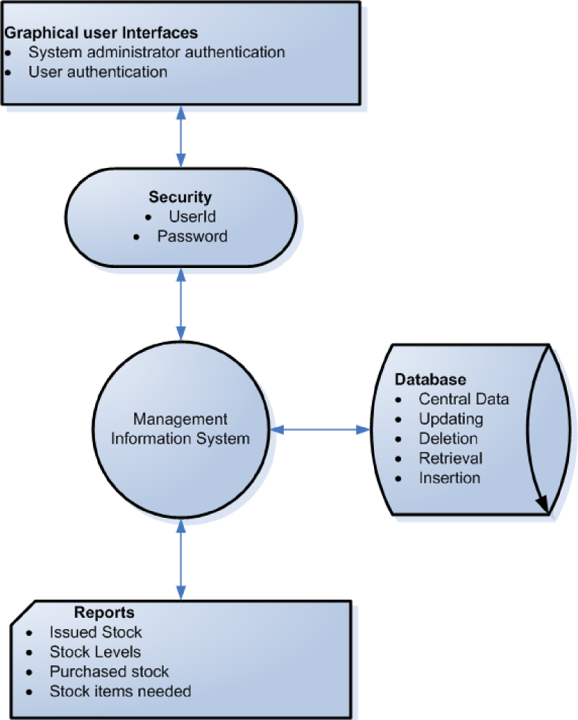

Figure 2: Architectural design for the proposed system

The dataow diagram below does show how information will ow in the proposed system.



Figure 3: Data ow diagram for the proposed system

**4.3.3 Mapping relationships**

The entities were identied with attributes and were duly put in relationships accordingly. The identier of an entity becomes primary key.

**Customer** (customer IDNo, type of business, amount, street, plot no., building, address date of assessment)

**Business type** (Business type, Type of business, amount)

**Stock ltem** (Stock Item ,Batch, Quantity, Date)

**Street** (Street , Name)

**Building** (Building ,Name,Street)

**Bank** (Bank Account No ,Name)

The diagrams below do map out the different relationships between entities for the system under study.

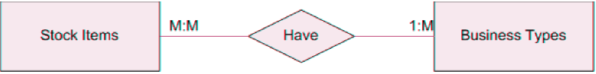

|  |  |
| --- | --- |
|  |  |

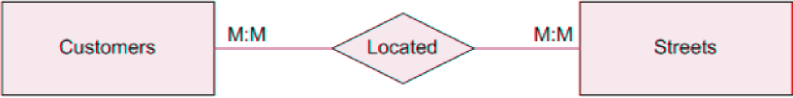



Figure 4: Mapping out different Relationships

**4.3.4 Final database schema**

**Customer** (customer IDNo, type of business, amount, street, plot no., building, address date of assessment)

**Business Type** (Business type IDNo, Type of business, amount)

**Stock ltem** (Stock Item IDNo,Batch, Quantity, Date)

**Street** (Street IDNO, Name)

**Building** (Building IDNO,Name,Street)

**Transaction** (Transaction IDNO,Customer,Assessment Year,Bank,Stock Item,Payment Date)

**Bank** (Bank Account No IDNO,Name)

The Entity Relationship diagram shows the different entities and the relationships for the pro-posed system.



Figure 5: Entity Relationship Diagram for the proposed system

**Data dictionary**

|  |  |  |  |  |
| --- | --- | --- | --- | --- |
| **ATTRIBUTE** | **DATA TYPE** | **LENGTH** | **KEY** | **DESCRIPTION** |
| Business type IDNO | Integer | 11 | Primary | Identies the business type |
| Business type | Characters | 50 |  | Business type name |
| Amount | numbers | 11 |  | Amount associated with business type |

Table 1: Business Type Table

|  |  |  |  |  |
| --- | --- | --- | --- | --- |
| **ATTRIBUTE** | **DATA TYPE** | **LENGTH** | **KEY** | **DESCRIPTION** |
| Transactions IDNO | Integer | 11 | Primary | Transaction identication number |
| Customer name | Characters | 15 | foreign | Refernces customer table |
| Assessment year | numbers | 4 |  | Year of assessment |
| Bank | Interger | 11 | foreign | References the bank table |
| stock Item | Integer | 11 | foreign | References the stock Item |
| Payment Date | date | 8 |  | date of payment |

Table 2: Transactions Table

|  |  |  |  |  |
| --- | --- | --- | --- | --- |
| **ATTRIBUTE** | **DATA TYPE** | **LENGTH** | **KEY** | **DESCRIPTION** |
| Stock Item IDNO | Integer | 11 | Primary | Stock Item identication number |
| Batch | Integer | 4 |  | Batch identication number |
| Quantity | Integer | 4 |  | Quantity of stock brought |
| Date In | date | 8 |  | date of payment |

Table 3: Stock Item Table

|  |  |  |  |  |
| --- | --- | --- | --- | --- |
| **ATTRIBUTE** | **DATA TYPE** | **LENGTH** | **KEY** | **DESCRIPTION** |
| Street IDNO | Integer | 11 | Primary | Street identication number |
| Street name | Characters | 50 |  | Street name |

Table 4: Street Table

|  |  |  |  |  |
| --- | --- | --- | --- | --- |
| **ATTRIBUTE** | **DATA TYPE** | **LENGTH** | **KEY** | **DESCRIPTION** |
| Buiiding IDNO | Integer | 11 | Primary | Building Identication number |
| Building Name | characters | 50 |  | Name of building |
| Street | Integer | 11 | Foreign | References Street table |

Table 5: building Table

|  |  |  |  |  |
| --- | --- | --- | --- | --- |
| **ATTRIBUTE** | **DATA TYPE** | **LENGTH** | **KEY** | **DESCRIPTION** |
| Customer IDNO | Integer | 11 | Primary | Customer identication number |
| Customer Name | Characters | 50 |  | Name of customer |
| Assessment year | numbers | 4 |  | Year of assessment |
| Building | Interger | 11 | foreign | References the building table |
| Plot No | Integer | 20 |  | Plot number of building Location |
| Address | Characters | 30 |  | Address |
| Phone | Integer | 20 |  | Telephone |
| Payment Date | date | 8 |  | date of payment |

Table 6: Customer Table

|  |  |  |  |  |
| --- | --- | --- | --- | --- |
| **ATTRIBUTE** | **DATA TYPE** | **LENGTH** | **KEY** | **DESCRIPTION** |
| Bank IDNO | Integer | 11 | Primary | Bank identication number |
| Bank name | Characters | 15 |  | name |

Table 7: Bank Table

**4.4 System Implementation**

This section guides system users about this software application and explains how the implemen­tation of the system was done and also how it executes its functionalities. The system application was implemented using a Linux environment and MySql was used to develop the database man­agement system. Java servlets were used to develop the code that links the database to the web browser to create forms and Html was used to create the graphical user interfaces for the client

**4.4.1 Security and accessibility to the database**

This is done through use of passwords to access the database .(Refer to appendix B).When access­ing the database the dialogue box request one to enter the user name, password and user group.

**4.4.2 Implementation**

This stage involves installing all components of the system that include hardware, software and training users of the system. The conversion plan for this system is parallel conversion given the advantage of low risks and being able to compare performance between the new system and the old one.

**4.4.3 Software life-cycle model**

A software life-cycle model is series of steps through which the product progresses. During the development of this system the waterfall model was employed. The approach has enforced disci­pline, documentation is a must and you cannot proceed to another phase without approval from the SQA group i.e. the FCIT.The use of the waterfall model provided us with a software application which is easy and cheap to maintain.

**4.4.4 Testing**

Since the software application is working prototype model, two types of testing were used i.e. ex­ecution based testing and non execution testing .Execution based testing is the process of inferring

certain behavioral properties of the product based in part on the results of executing the product in a known environment with selected inputs. Non execution testing for the specications and this involved validation. Validation helped to determine whether the application as a whole satised the specications or objectives.

**4.4.5 User manual**

In this section we look at information that is needed to utilize the application by the end user. It focuses on the user learning how to start application, use the application and close the application. The user to be able to start the application does need to log on the system using a valid user name and password and there are three options of Login, clear and close.

In addition to that if other users log on to the application, they can have access to the authorized user screen with many options including register patient, delete patient, update patient and the reports option.

**4.4.6 Application Interfaces**

LOGIN FORM:(Refer to appendix B).It enables the user to login and have access to the system and the database.

USER FORM:(Refer to appendix B).Enables users in their capacity to enter data accordingly.

MANAGER MENU:(Refer to appendix B).The manager performs the various duties as required of him/her.

NEW BUSINESS FROM:(Refer to appendix B).This form is used by the data entrant to register new business entities.

ACCOUNTANTS FORM: (Refer to appendix B).The accountant uses this particular form to enter data for business types,bank accounts information,payments and assessments.

LICENCE FORM: (Refer to appendix B).The stocker uses is form to make all the necessary up-dates on the invetory (licences).

ALERT FORM: (Refer to appendix B).Flags the stocker to remind him/her of stocks needed.

REPORT FORM: (Refer to appendix B).It shows the varoius numbers of inventory items in stock.

**CHAPTER FIVE**

**5 DISCUSSION, RECOMMENDATION AND CONCLUSIONS**

**5.1 Introduction**

This chapter summarizes the achievements of the project, limitations encountered as well as the recommendation thereafter. The main objective of this project was to design an Inventory manage­ment information system for Njeiforbi Bakery Buea. The project also meant to create a more secure way of storing inventory data and an efcient way of generating monthly inventory reports.

**5.2 Achievements**

The system is user friendly hence little difculty is expected in running this application. It will greatly reduce on the time that it takes capture inventory information and the time it takes to prepare monthly health reports will reduce considerably. This will be achieved with only a click of the button, all the required procedures for generating reports on the will be executed with the assumption that all inventory information exists in the system.

The utmost achievement of the project has been to develop an online inventory information man­agement system to cater for inventory and that can quickly enable managers generate monthly health reports. For example its possible for managers to know the amount of stock item left at the shelf plus its monetary value.

Information systems do play an enormous role in data management of organizations that employ them. In organizations that deal in vast inventory, information systems play vital roles i.e. the do improve on your inventory data accuracy, reduce on your lead time, increase the velocity of your operation, eliminate misalignment from your process, eliminates variations in inventory and replenish based on market demand.

The researcher did establish the strengths and weaknesses, and it is from this that software was designed that is implemented to input inventory information, retrieve and generate the necessary reports. The system can allow future adjustments to integrate future demands. The project will

serve as a knowledge base to other researchers and interested parties. It will also be used as a template for developing the real database system for Njeiforbi Bakery Buea. The designer does hope that the online system will help Njeiforbi Bakery Buea will minimize the problems with the manual inventory system being employed.

**5.3 Limitations**

In the early stages of development of the database, PHP was sought of to be used to implement the code but due to the fact that the researcher had diminutive knowledge about the scripting language, he had to change to java script which he had learned in the his rst semester.

This called for the learning on how to use java servlets hence the time taken for implementation was longer than the planned time for the researcher to be able to complete the project.

The other limitation was that of the nances to fund the all project in terms of printing, stationery, research assistants plus other needed materials.

**5.4 Conclusion**

The database will enable the update, retrieval, deletion, and generation of Inventory reports ac­cordingly. The complete and appropriate implementation of this Inventory management system on stock items will yield signi cant advantages to the organization.

**5.5 Recommendation**

Njeiforbi Bakery Buea should establish an automated inventory process to manage inventory data and ease on the process of generating monthly reports. Computerization of services and processes is required to effectively benet from this application. There are other aspects that the researcher did not put into consideration like the people who assess the various businesses, where the stock comes from etc hence future researches can put all those considerations in order to come up with an efcient and a more representative functional automated inventory information system.

**References**

1. AcaDemon, (2005) *Inventory Control Systems-Inventory control systems as related to overall production for a company.* [Online] <http://www.academon.com/lib/paper/57872.html> [Re­trieved] 15th September 2005
2. Amoro, P. (2004). *Project report entitled Automation of Business Transactions of FRIECA Pharmaceuticals Limited*
3. Bwire,S. (2004),*Project* *report entitled Stores Management Information System*
4. Cameron Balloons Virtual Factory on Biz/ed. *Cameron Balloons Virtual Factory on Biz/ed. Stock Control Systems.* [Online][httpwww.bized.ac.uk/virtual/cb/factory/purchasing/theories2.htm](http://httpwww.bized.ac.uk/virtual/cb/factory/purchasing/theories2.htm) [Retrieved] May 24th, 2005
5. Constitution of The Republic of Uganda (1995).*Article* *191of the constitution of the Republic of Uganda (1995)* (12).LDC Publishers Printing Press.
6. Kakeeto,K. (2003),*Project* *report entitled Inventory Management System for Graphic sys­tems Uganda limited.*
7. Kanyanyuzi,R. (2005),*Project* *report entitled Fixed Asset Inventory System for Makerere University.*
8. Kibera,N. (1996),*Introduction to Business, A Kenya Perspective.* Kenya Literature Bureau.
9. Laudon,K.(2001),*Management* *Information Systems, Managing the Digital Firm.* The 7th Edition: Prentice Hall.
10. Local Government Act (1997) *Section 79 of the Local Government Act (1997)* (7).P.P.P.C Entebbe.
11. Moskowitz,R.(1995)*The* *Small Business Computer Using your computer for inventory con­trol.* [Online] <http://knowledgetree.com/computerarticles/inventory-control.htm>. [Retrieved] The 29-July 2005.

12. Public Relations Unit Kampala City Council (2005),*To* *provide and facilitate the delivery of Quality, sustainable customer oriented services efciently and efectively.*TheNew Vision, Monday, May 2,2005 Press Release.

APPENDICES:

Appendix A: Interview guide

Am in the process of designing an Automation of Inventory Process for Njeiforbi Bakery Buea, i therefore request you to ll and answer the questions there in. Your cooperation will be welcome. What method is being used to control/monitor the stocks of license

What system is being used to manage the stocks of the organisation?

-

* —————————————————————————
* —————————————————————————
* —

What are the problems and dif culties do you meet in the process of capturing and storing of information using the above system?

* ————————————————————————————————————‑
* ————————————————————————————————————-How do you determine the stocks that are to be purchased?
* ————————————————————————————————————–
* ————————————————————————————————————– When and how are the stock levels of various items determined?
* —
* —

|  |  |  |
| --- | --- | --- |
| NAME -  DESIGNATION | | |
|
| - | |  |
| SIGNATURE |  |  |
| Thanks very much, |  |  |
| KATENDE KENNETH KIDONGE(Researcher) | |  |
|  | 35 |  |

Appendix B: Application Interfaces

LOGIN FORM:Login form that enables the user to login and have access to the system and the database.

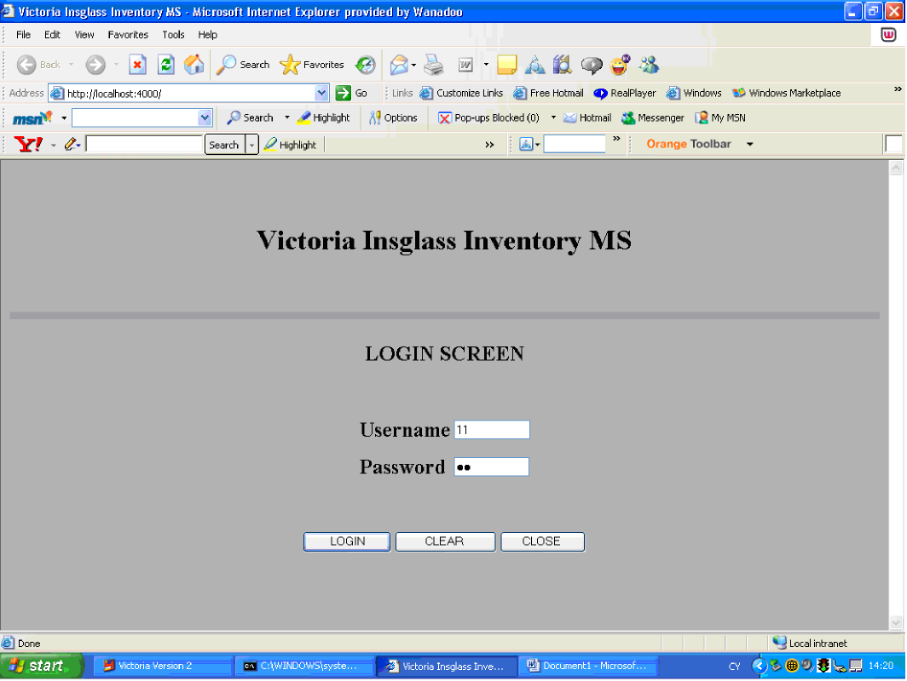

Figure 6: Login Form:This form enables the user to login and have access to the system and the database

USER FORM:System user form enables users in their capacity to be able to enter data.

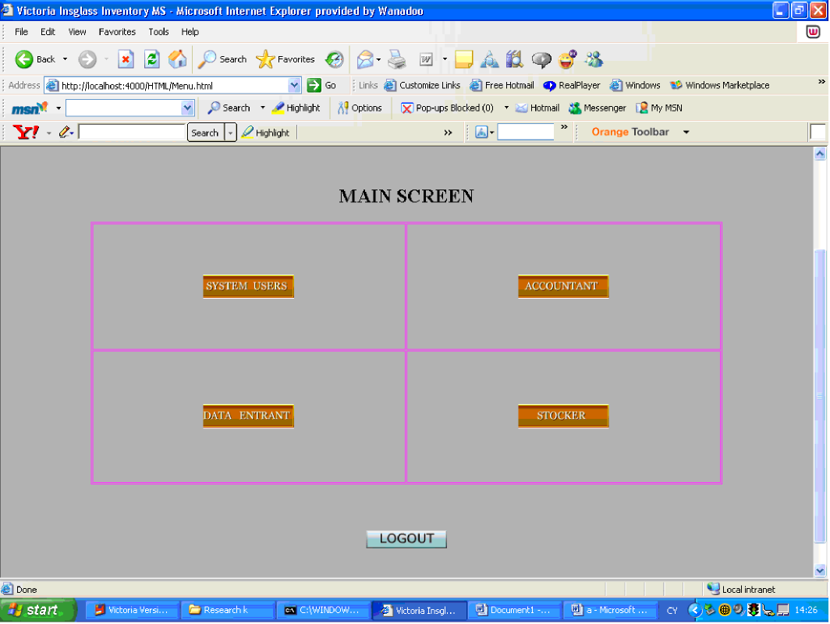

Figure 7: System User Form:This form enables the users in their capacity to perform various functions

MANAGER MENU:The manager performs the various duties as required of him/her.

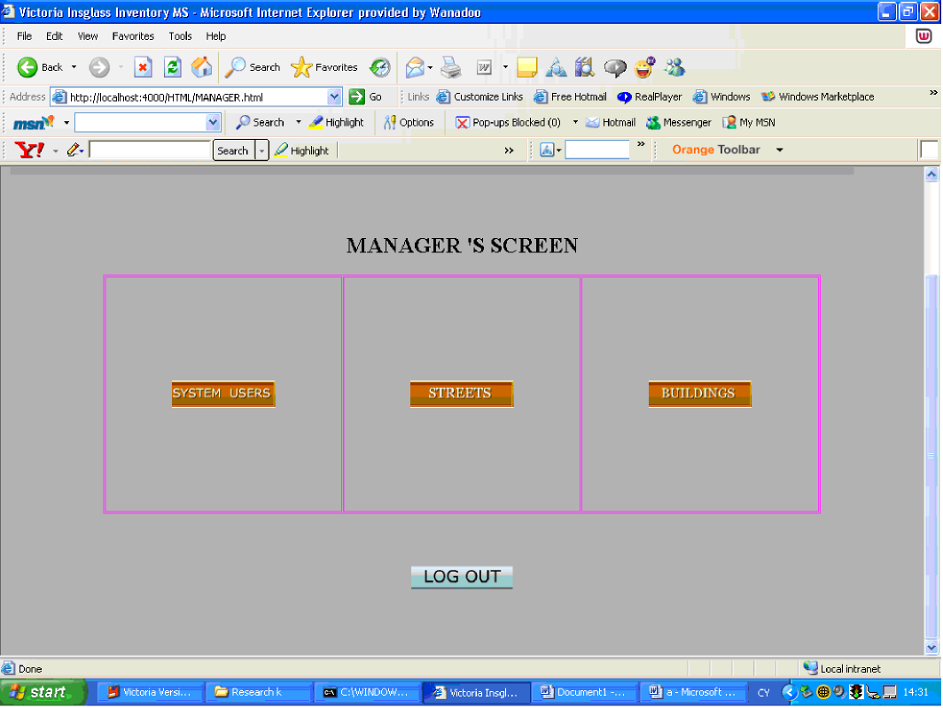

Figure 8: Managers Menu:This form enables the Manager to enter the necessary information using this form

NEW BUSINESS FROM:This form is used by the data entrant to register new business entities.

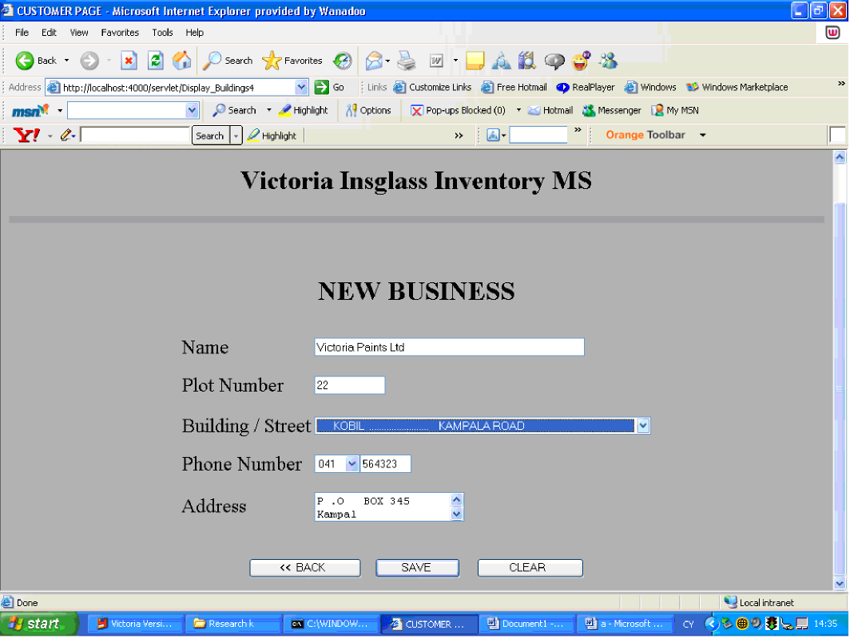

Figure 9: New Business Form:This form enables the Data-entrant to register new businesses

ACCOUNTANTS FORM:The accountant uses this particular form to enter data for business types,bank accounts information,payments and assessments.

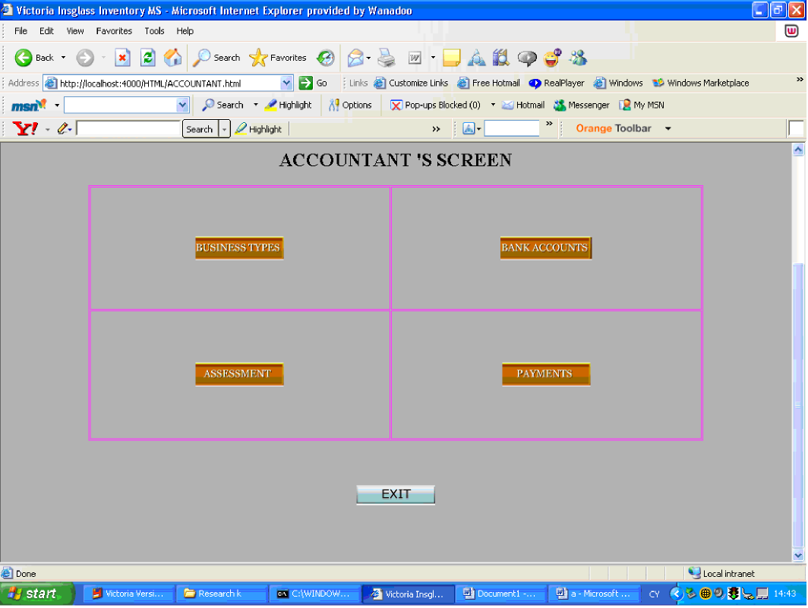

Figure 10: Accountants form:This form enables the accountant to register various details

LICENCE FORM:The stocker uses is form to make all the necessary updates on the invetory (licences).

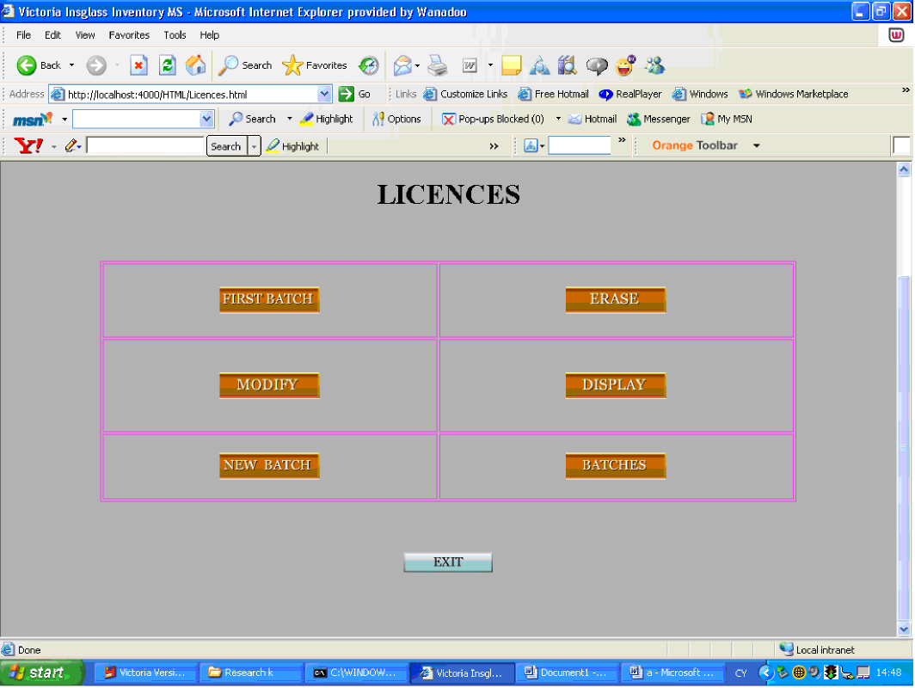

Figure 11: Licences Form:Used by the stocker to enter various inventories

ALERT FORM: Flags the stocker to remind him/her of stocks needed.

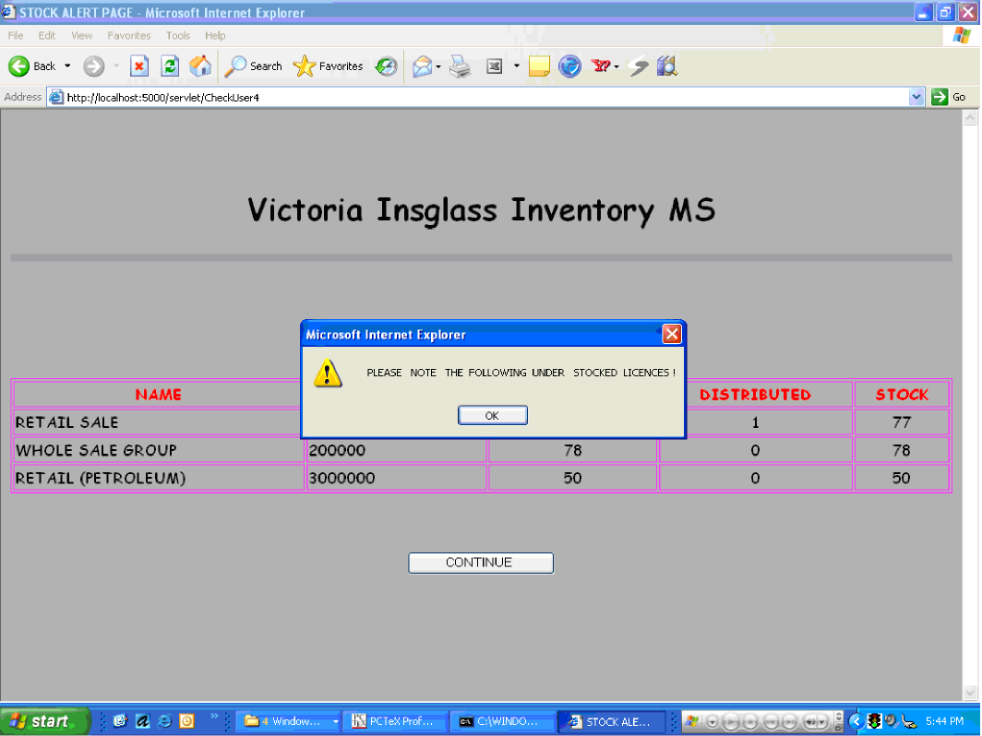

Figure 12: Alert Form:It alerts the stocker which various stock items need to be re-ordered

REPORT FORM: It shows the varoius numbers of inventory items in stock.

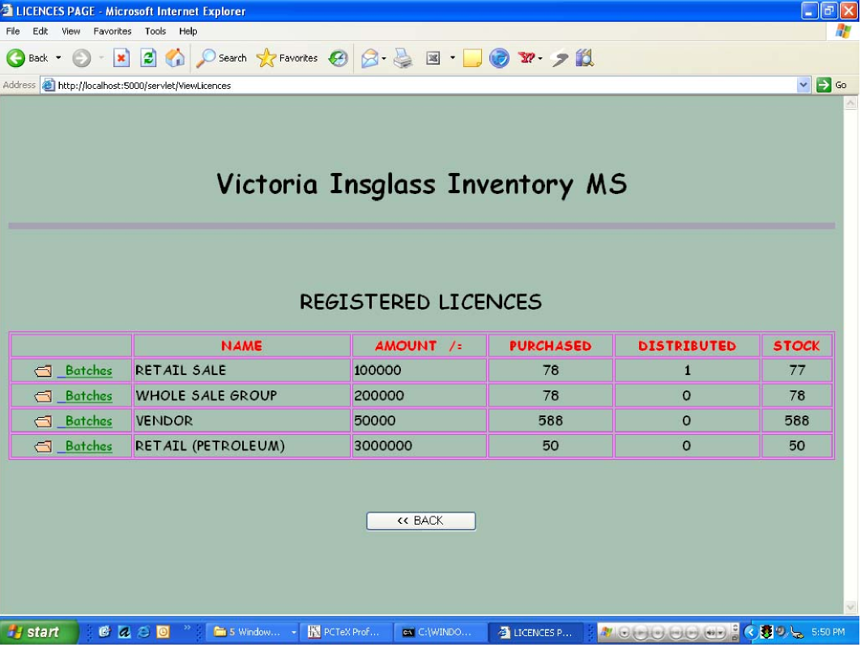

Figure 13: Report:This form shows the different available stock items and there numbers

43